Bluetooth Multi-Color Control Unit APP useage
Although installation instructions may be provided, it is essential that buyers understand RedLine LumTronix Inc vehicle lighting products are vehicle related and require installation and vehicle knowledge. Installation skill and experience varies so it is recommended the RedLine LumTronix Inc vehicle lighting products are installed professionally. RedLine LumTronix Inc are not responsible for any damage incurred by the improper installation of any products installed professionally or unprofessionally.
Always bench test this product before installation, so you may discover any problems before you spend the time to fully install this product.
- To use the Bluetooth feature instead of the remote, you will need to download the appropriate APP. If you have an apple IOS device such as IPhone or and IPad you will need to download the current “HappyLighting” APP from the Apple APP store. If you have an Android device, you will need to download the current “HappyLighting” APP from the Android APP store.

- Once downloaded open the app.

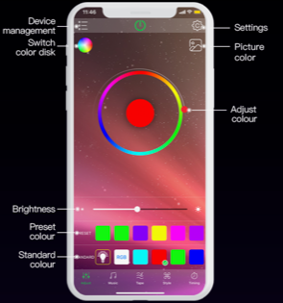 | 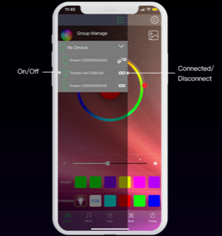 | 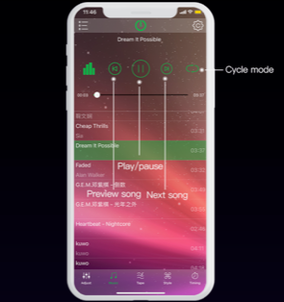
From the home screen you can select colors from a color wheel or from a preset color. You can also select the brightness of the color. | Click on device management find the control unit and pair to it. You can connect or disconnect from assigned control units. | Selecting from the menu at the bottom, select music and see your lighting dance to the music.
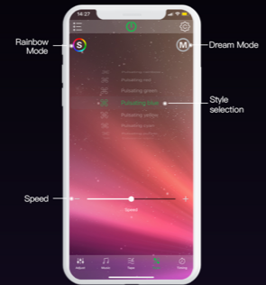 | 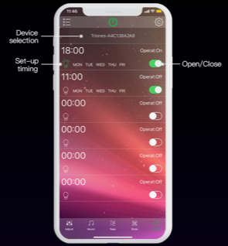 | 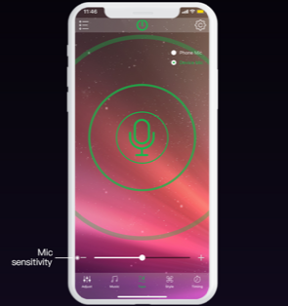
Select a mode that pleases you. | Now setup the intermittent timing of the mode. | Select Mic mode and speak into your phone and see how your lights dance to your voice.
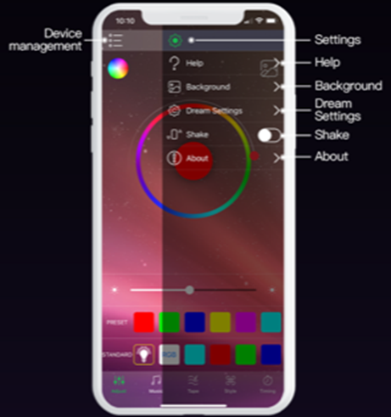 | 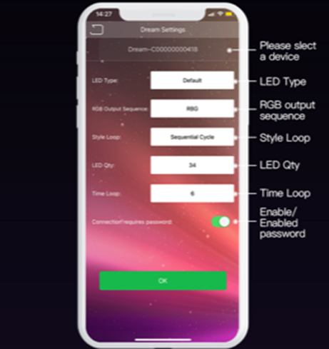
Select the gear wheel on top right of screen and change settings or get help on how to use this APP. | In dream settings you can setup your light settings.

- Take note that there will be a “RedLine LumTronix” APP, name to be announced. Which will allow you to manage many control units located throughout your car with our headlights or Light’Em ™ LED strips, allowing you to name the compartment from which they are located.

