Bluetooth Multi-Color Control Unit and Harness Installation Instruction

Although installation instructions may be provided, it is essential that buyers understand RedLine LumTronix Inc vehicle lighting products are vehicle related and require installation and vehicle knowledge. Installation skill and experience varies so it is recommended the RedLine LumTronix Inc vehicle lighting products are installed professionally. RedLine LumTronix Inc are not responsible for any damage incurred by the improper installation of any products installed professionally or unprofessionally.

Always bench test this product before installation, so you may discover any problems before you spend the time to fully install this product.

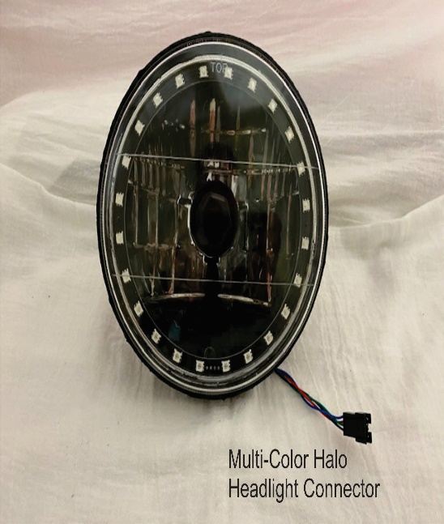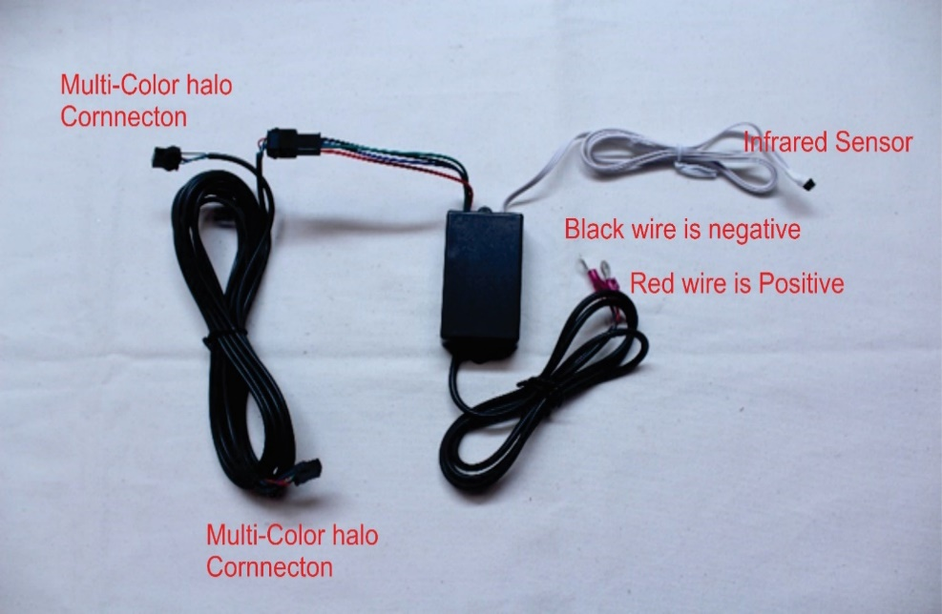

- Turn off your car by taking your keys out of the ignition.

- Remove any headlight bezels and retaining rings.

- Pull the headlight away from the car and disconnect the headlight wire harness connector to completely remove the headlight.

- Place your new Multi-Color headlights near the light bucket, connect the supplied H4 Ceramic Harness to your headlights and then to your OEM headlight wire harness. The H4 Ceramic harness is supplied to keep the heat from the bulb from melting your OEM headlight connector. NEVER leave headlight hanging from harness.

- Vehicles with 4 headlights; Each Headlight we sell is equipped with high and low beam bulb. When replacing your original high beams you may connect your high beam headlight connector on your OEM headlight harness directly to the two vertical prongs on the back of the bulb (not recommended, or use our H4 Ceramic Harness because the heat can damage your OEM headlight connector) or to the two vertical prongs on the H4 Ceramic Harness we provided. The horizontal prong not connected (either on the bulb or our harness) is the low beam prong which will not have any power and will not cause you any problems. If you use the provided H4 Ceramic Harness you may bend or cut the unused prong.

- Next run the Multi-Color Halo Harness from the cab. Choose an end connector then run it from the cab to the first headlight either from the passenger or drivers’ side, whichever is convenient to you. The middle in-line connector on the Multi-Color Harness is the connector to be connected to the first headlight. Now run the harness from that first headlight over to the second headlight in the grill to avoid any contact with the radiator.

- Connect each headlight connector on the multi-color halo harness to the multi-color halo connector on the headlight.

- Replace headlight into light bucket. Place supplied headlight cushions (small square sponge foam) into the retaining ring. See “Installing Retaining Ring Headlight Cushions Installation Instructions” to learn how to install. When reinstall the retaining rings but do not over tighten screws. OVER TIGHTNING HEADLIGHT BEZELS OR RETAINING RINGS MAY CAUSE HEADLIGHT GLASS TO CRACK under some driving conditions. Reinstall headlight. RedLine LumTronix INC is not responsible for any cracked glass after installment. If you do crack your lens you can have it replaced by RedLine LumTronix Inc for a fee, so you do not lose your investment.

- Place the red wire of the Multi-Color control unit on a positive battery source or to your ignition switch. Connect the black wire on a negative battery source or to a good chassis connection.

- Skip this step if you are installing a Radio Frequency (RF) control Unit. Place the Infrared sensor in a place where you can point the wireless remote at. You need to point in a line of sight for it to work. The brighter it is outside in the sun you might have to point closer to the sensor. A lot of people place the infrared sensor just inside the front windshield inside of the cabin of the car, this way they can point at the infrared sensor from inside of the car or outside of the car to change colors anytime they want.

- You must adjust your headlight beam to make sure you see the road and not blind any oncoming drivers. THIS STEP MUST ALWAYS BE COMPLETED because our focus beam is different than any other headlight. Use “Adjusting your headlights after Installation” instructions to adjust your headlights found in the How to section on our website.

- If your main beam is dim or blinking off/on, it is because your switch is overheating because it cannot effectively supply a constant supply of power to keep them on. Switches made back then were not made for the wattage necessary to for modern day incandescent bulbs. To solve this problem, we sell a upgrade harness with relays that will resolve this or you can purchase higher current headlight switch made for your vehicle which can handle Halogen/Xenon bulbs. Our upgrade harness “2 Lamp 2 relay headlight upgrade harness” EH-001 is for two headlight systems or “4 Lamp 2 relay headlight upgrade harness” EH-002 is for four headlight systems.

- To use the Bluetooth feature instead of the remote, you will need to download the appropriate APP. If you have an apple IOS device such as IPhone or and IPad you will need to download the current “HappyLighting” APP from the Apple APP store. If you have an Android device, you will need to download the current “HappyLighting” APP from the Android APP store.

- Once downloaded open the app.

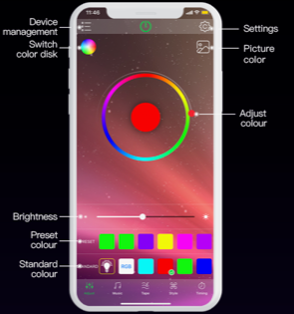 | 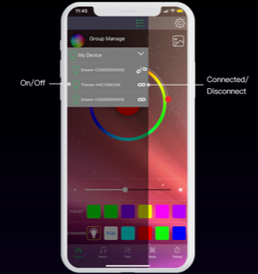 | 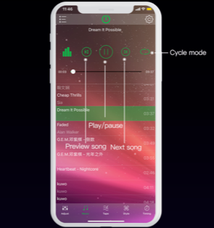
From the home screen you can select colors from a color wheel or from a preset color. You can also select the brightness of the color. | Click on device management find the control unit and pair to it. You can connect or disconnect from assigned control units. | Selecting from the menu at the bottom, select music and see your lighting dance to the music.
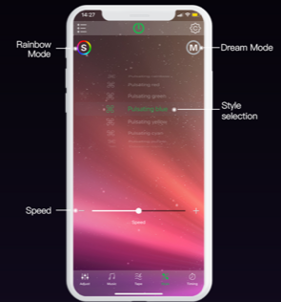 | 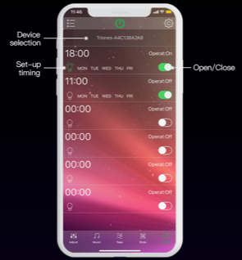 | 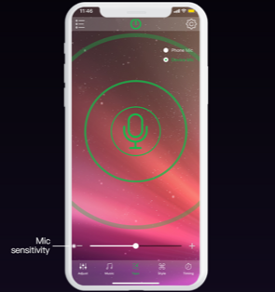
Select a mode that pleases you. | Now setup the intermittent timing of the mode. | Select Mic mode and speak into your phone and see how your lights dance to your voice.
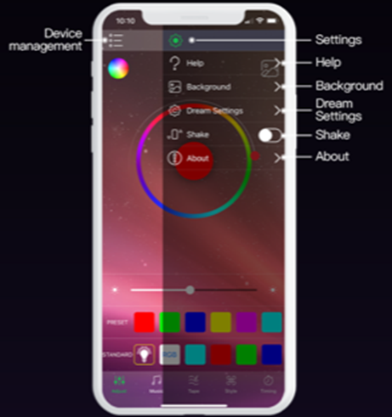 | 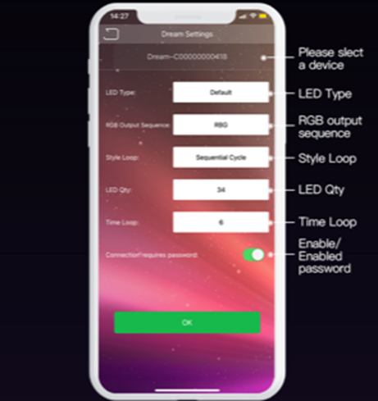
Select the gear wheel on top right of screen and change settings or get help on how to use this APP. | In dream settings you can setup your light settings.

- Take note that there will be a “RedLine LumTronix” APP, name to be announced. Which will allow you to manage many control units located throughout your car with our headlights or Light’Em ™ LED strips, allowing you to name the compartment from which they are located.

